Comparison between SNF, NNF, PNF

Parameters in the auxiliary feedback loops are tuned such that

* Average Bmal (At) matches SNF At0
* Temporal dynamics of Ptot matches SNF (max(Ptot), period, amplitude)

1. SNF 0L8

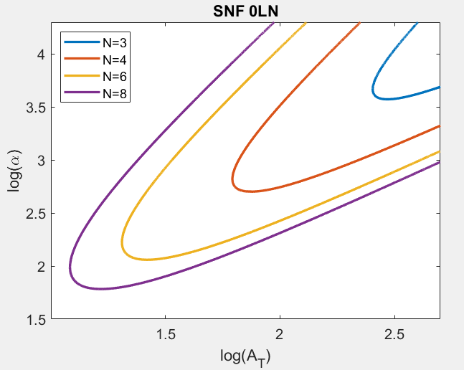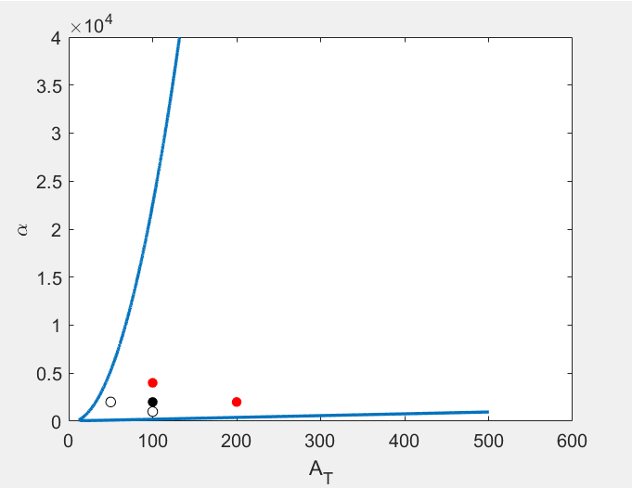

At=100, alpha=2000

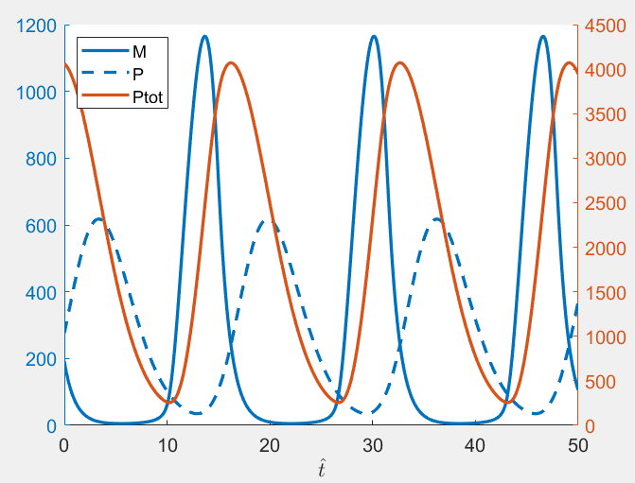

max(Ptot) ~ 4,000

period(Ptot) ~ 16

NNF 0L8

delta= 0.26, Amax=118, Vmax=1.5

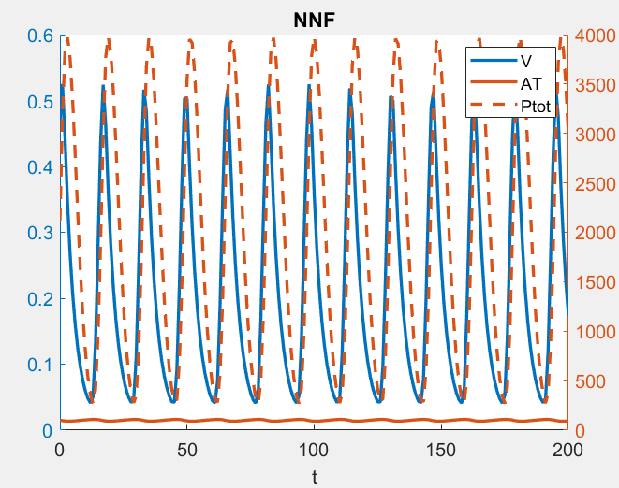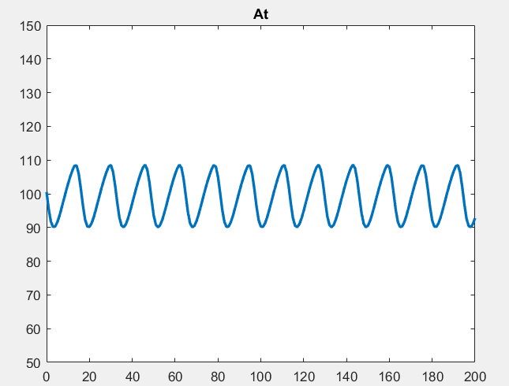

avg(At)~ 100, max(Ptot)~4,000 , period(Ptot)~16

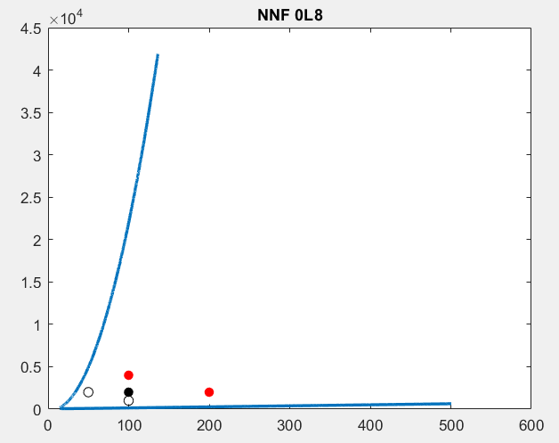

PNF 0L8

delta= 0.12, Amax=228, Rmax=6.3

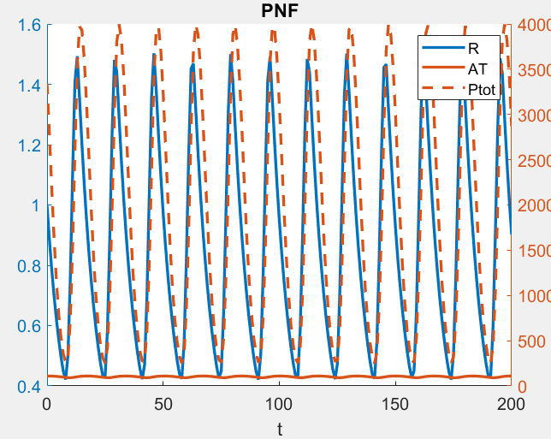 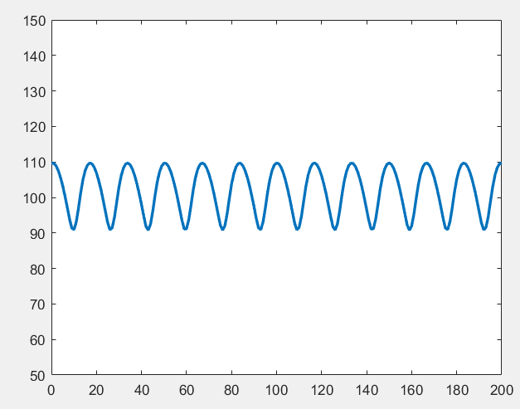

avg(At)~ 100, max(Ptot)~4,000 , period(Ptot)~16

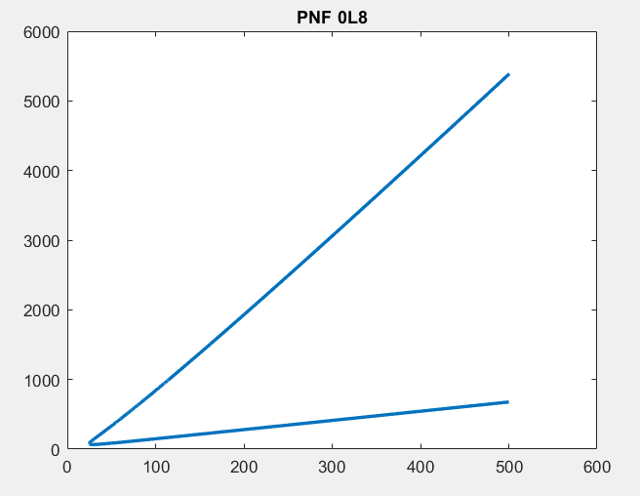

Overlay of At-alpha bifurcation

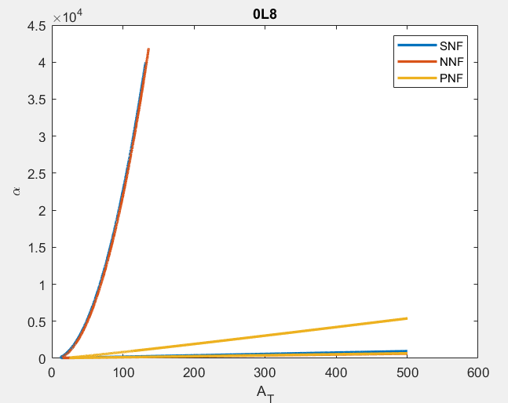

PNF oscillatory region is significantly smaller than SNF and NNF

0M8 models

Km = 1, beta=3.8

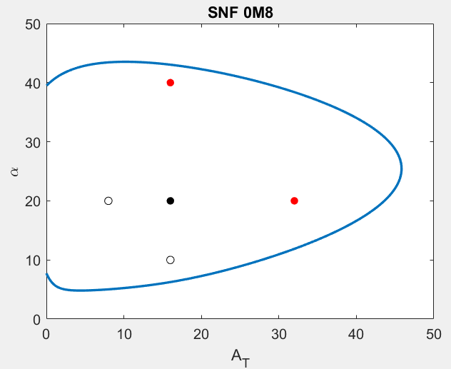 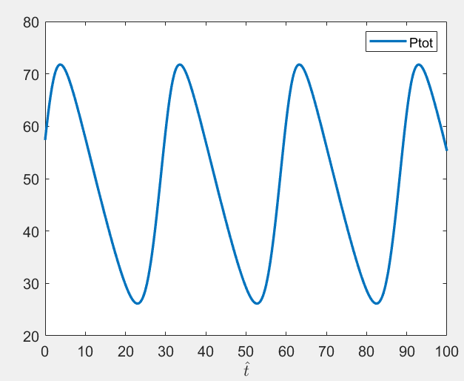

At=16, alpha=20,

max(Ptot)~75, period(Ptot)~30

NNF

delta= 0.06, Amax=114, Vmax=38

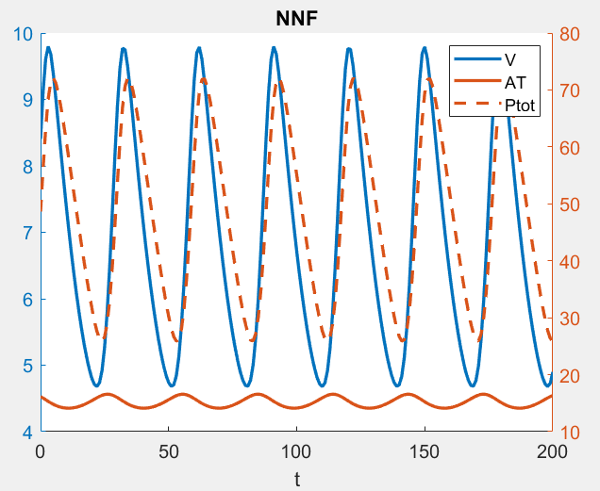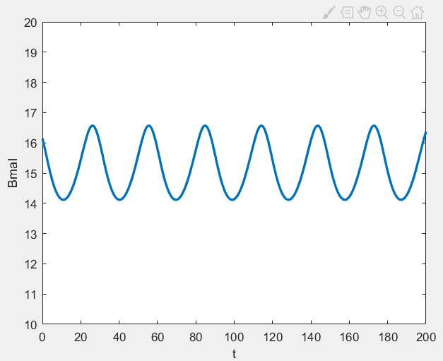

avg(Bmal)~16,

max(Ptot)~75, period(Ptot)~30

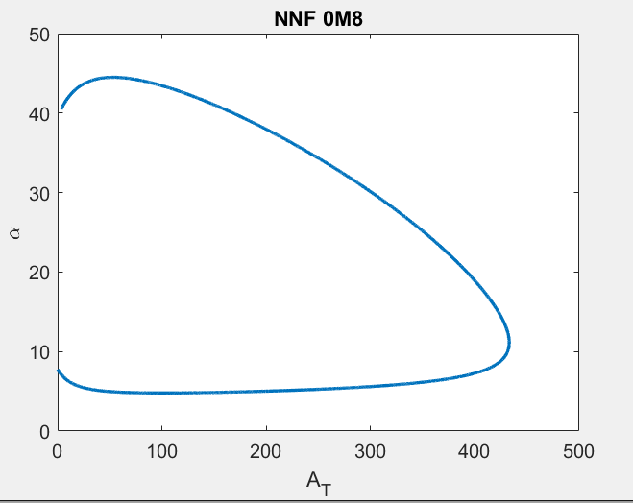

NNF has a larger oscillatory region than SNF

PNF

delta= 0.1, Amax=25, Rmax=11

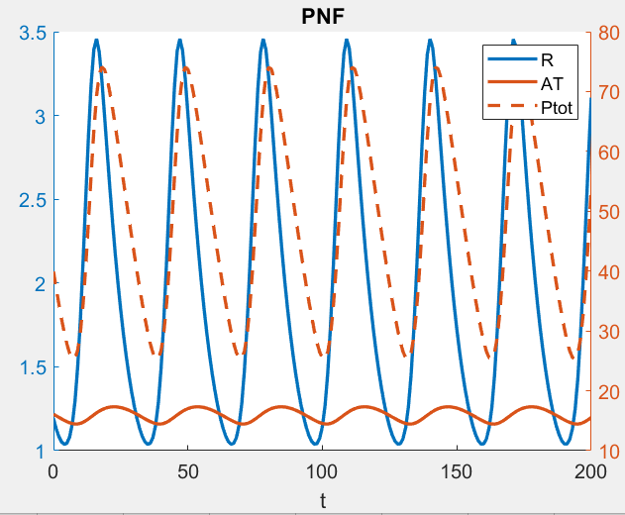

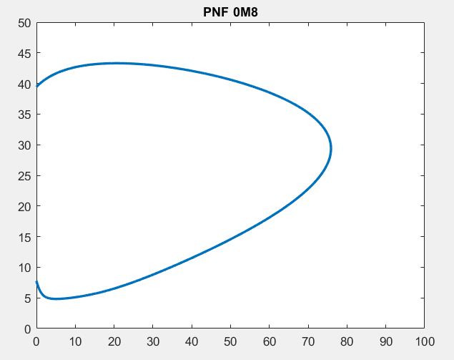

Overlay of SNF, NNF, PNF 0M8

